# CO 417 - Advanced Computer Graphics

Coursework 1

Report

Images were generated using our own C++ code.

## Part 1

Our chosen weighting function is the function described in Debevec & Malik’s paper ‘Recovering High Dynamic Range Radiance Maps from Photographs’.



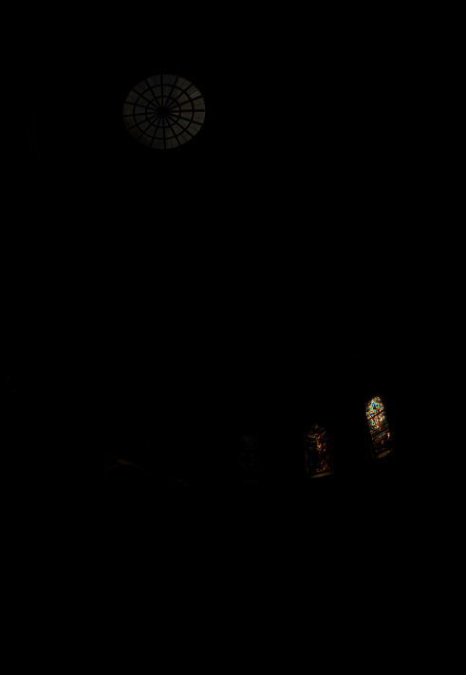

*toneMapped.ppm*

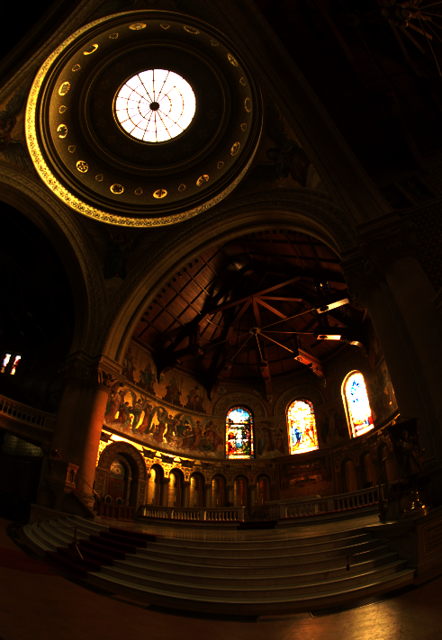

*exposure.ppm* (8.8 Stops)

We found this exposure value to produce the most aesthetically pleasing result.

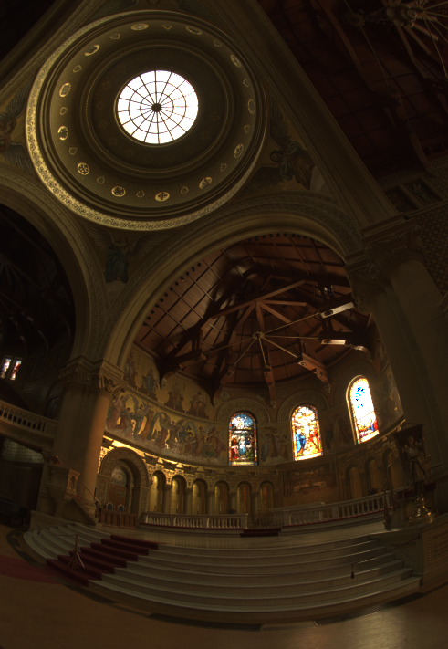

*gamma.ppm*

Gamma Value **2.2** - Exposure **6** stops

We found this combination to produce the optimum result.

We detected a dynamic range in *HDR.pfm* of 1:191696. This was calculated by taking the largest pixel value in the hdr image (the sum of the pixel’s components) and dividing it by the smallest pixel value in the hdr image.

## Part 2



*rVectors.ppm*

XYZ -> RGB

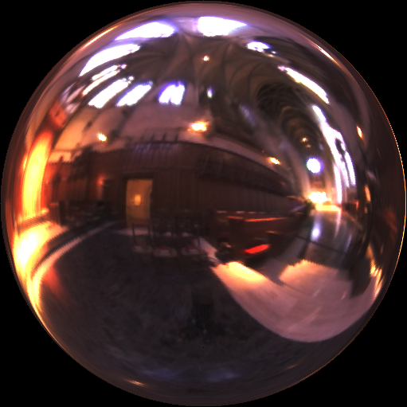

sphere.ppm

Gamma Value = 2.2

No alteration to Exposure